**Registration System 1.0**

**Student User Documentation**

**2016**

**NOTE: If you do not yet have an account you must create one. To do so you must visit the login page and click the “registration” link. The administrator will notify you when the account has been activated.**

**Navigation**

As a student you may register or drop courses. At the top of the app you have the following options you may select:



*Course listing* shows you all the courses currently offered*.*

*Recommended courses* show you courses that you are eligible to enroll in*.*

*My courses* show you the courses you are currently registered in.

*Profile* shows basic information about your user account, and also lets you change your password.

*Logout* will log you out of the application.

**Registering for Courses**

You may register for courses under “Course Listing” or “Recommended Courses”. In both cases you will register for courses the same way:

1. Select the course you want to enroll in by selecting the checkbox next to the course listing:



2. Click the submit button at the bottom of the application:



**Dropping Courses**

You may drop courses under “My Courses”.

1. Select the course you wish to drop by selecting the checkbox next to the course listing:



2. Click the submit button at the bottom of the page:



You may not always be able to drop a course. The application will not let you drop a course that is beyond the withdrawal deadline.

**Viewing Courses**

“All Courses”, “My Courses”, “Recommended Courses” sections show you basic information about the course. Under each section you may view more details by clicking the name of the course. For example, under “All Courses” you will see listings similar to the below picture:

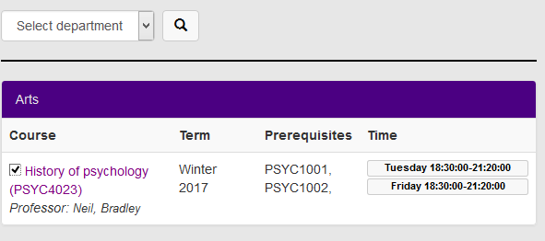

Clicking on the “History of Psychology (PSYC4023” will show you more information about the course:

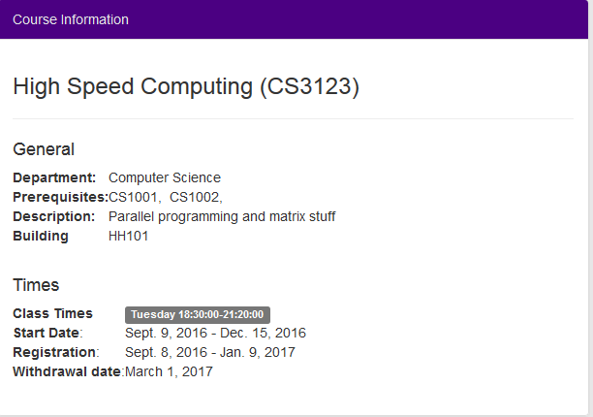

You may search for courses by course id, category, or both. The below diagram shows the search feature:

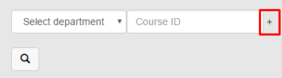

Notice the marked “+” sign in red. Clicking this icon will add an additional search filter.